FrameWork Design :

I have used the Page Object Repository Framework to Design the code

In this Framework we used Page Object Model which having the different pages for Performing the Different Operations.

We have the config file where we can Config the URl and different Configuration

We have the Locators defined in the config File .

We can change/add the Locators based on the Requirement.

Folder Structure is like :

Import the Project using zip file or clone it from git hub <https://github.com/santoshkushwah024/Add_cart_for_Mamacita_Brand>

After Importing Navigate to

**/[src](https://github.com/santoshkushwah024/Add_cart_for_Mamacita_Brand/tree/master/src)/**[**main**](https://github.com/santoshkushwah024/Add_cart_for_Mamacita_Brand/tree/master/src/main)**/**[**java**](https://github.com/santoshkushwah024/Add_cart_for_Mamacita_Brand/tree/master/src/main/java)**/**[**com**](https://github.com/santoshkushwah024/Add_cart_for_Mamacita_Brand/tree/master/src/main/java/com)**/[utils](https://github.com/santoshkushwah024/Add_cart_for_Mamacita_Brand/tree/master/src/main/java/com/utils)/Constants.java**

and change the Config file path as per your System File Location .

For getting File location rightclick on Config file and click on properties and then copy the path

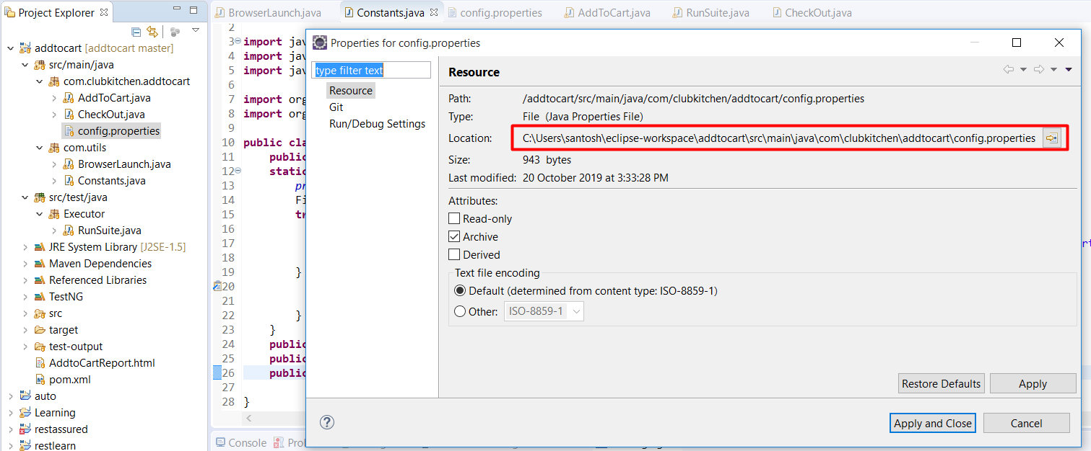

and change in Constants.java file as below:

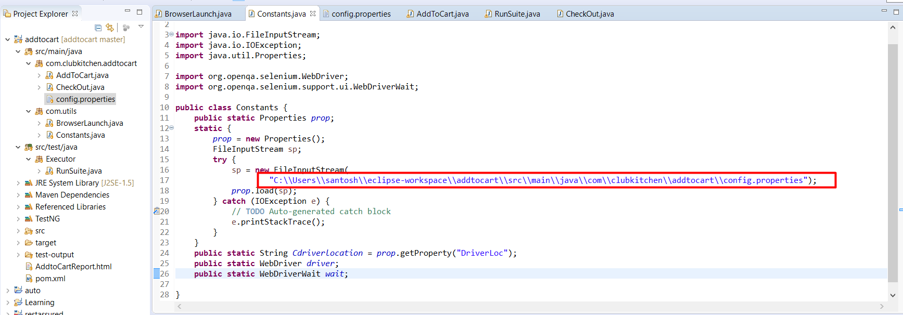

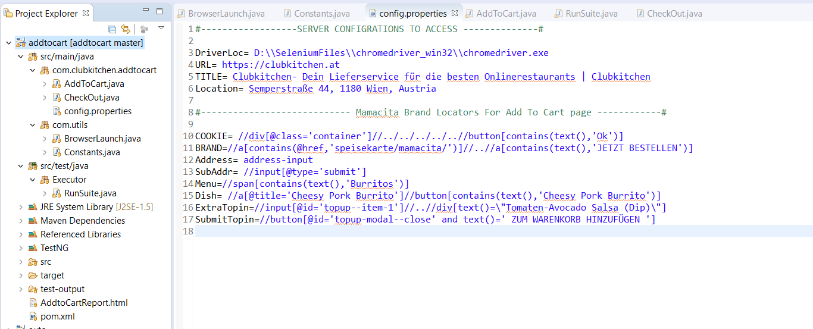

Navigate to **config.properties file and change the Chromedriver location** as per your System Driver Location.

DriverLoc 🡪 D:\\SeleniumFiles\\chromedriver_win32\\chromedriver.exe

To you System Driver Location.